# P6 – story board of UI

In this section I will be detailing the goals that I want my game to reach. This will include the title page, menu and the games different scenarios.

## Title Page

Above is my title page. I am also going to use it as the menu page for when players pause the game. The background shall be running a simulation of the game. This could either be in the form of a video of someone playing the game or it could be created live giving a more diverse result. The Title and menu pane will not interfere with the game mechanics (the bombs will not bounce off of the Title.

# Game scenarios

## Start-up

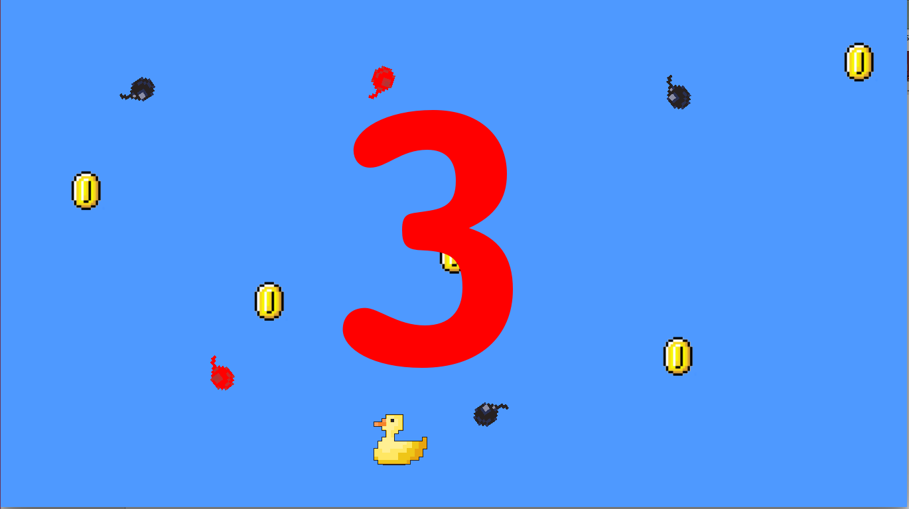When the game begins all objects will be randomly generated. As shown above a countdown from 3 will begin to give the player some time to ready themselves for the beginning of the game. The Duck character will be generated in the centre of the screen but will instantly be placed in-line with the mouse x-coordinate. This Character can then be moved by the mouse. All other sprites will not be able to move until the countdown has finished, then the game will commence.

# Data Dictionary

|  |  |  |  |
| --- | --- | --- | --- |
| Name | Purpose | Data Type | Reasoning |
| frame_width  frame_height | Store the width/height of the users screen. | Integer | Is a small enough data type that I am not worried about running the application on a computer with low amounts of RAM, big enough to store the largest/multi screen displays. |
| colour_depth | Store the amount of colour bits required. | Integer | Small enough to keep RAM usage low, has the best compatibility with library programs without changing to a different data type. |
| frame_resizeable  frame_fullscreen | Stores whether the user wants the screen to be resizeable/full screen | Boolean | The answer is only going to be true/false and boolean is the best and smallest way to store this. |
| use_opengl  use_hardware | Stores whether the user wants the game to use their graphics card/openGL | Boolean | The answer is only going to be true/false and boolean is the best and smallest way to store this. |
| Background  sprites | Stores the sprite sheet and background going to be used. | Surface | Very good at adjusting the data to be minimal as well as adjustable (i.e. cutting sprites from the sprite sheet). It is also very good at interfacing with SDLdotNET (the graphics library I am using) |
| Video | Store the output to the user, comes from the combination of background, sprites and the physics engine. | Surface | Very good at adjusting the data to be minimal as well as adjustable (i.e. cutting sprites from the sprite sheet). It is also very good at interfacing with SDLdotNET (the graphics library I am using) |

## D2

### Pseudo Code

### class program:

### rnd = Random

### ss (SpriteSheet)

### duck (Duck)

### Bomb[10] bombs

### Coin[10] coins

### scoreWord(scoreWord)

### tens(TensScore)

### units(UnitsScore)

### gameOver(GameOver)

### void onInit:

### new Duck

### new ScoreCard

### new TensScore

### new UnitsScore

### new GameOver

### for i is less than amount of bombs:

### new bomb[i]

### for i is less than amount of coins:

### new coin [i]

### end void

### bool checkBombsIntercept takes i(integer):

### if any intercections:

### return true

### else

### return false

### end bool

### void newScore takes score(integer):

### change score counter to score(integer)

### end void

### bombStepper(integer) = 0

### coinStepper(integer) = 0

### delayer(integer) = 0

### score(integer) = 0

### secDelayer(integer) = 200

### if secDelayer is bigger than 150 && secDelayer is less than 200:

### quit aplication

### end if

### for i(integer is less than amount of bombs:

### if checkBombsIntercept(i)

### show gameover

### secDelayer = 0;

### end if

### end for loop

### for i(integer)is less than amount of coins:

### if checkCoinsIntercept(i):

### if delayer is greater than 10:

### score++

### newScore(score)

### coins[i] set Y = 0

### coins[i] set X = rnd.Next(FRAME_WIDTH)

### coins[i] set DY = rnd.Next(1, 4)

### delayer = 0

### end if

### end if

### end for loop

### if bombStepper is greater than 60:

### for i(integer)is less than amount of bombs:

### if bombs[i] get Sprite is equal to 2:

### bombs[i] set Sprite = 1

### end if

### else

### bombs[i] set Sprite = 2

### end else

### bombStepper = 0

### end for loop

### end if

### if coinStepper is greater than 2:

### for i(integer) is less than amount of coins:

### if coins[i] get Sprite is equal to 10:

### coins[i] set Sprite = 4

### end if

### else:

### coins[i] set Sprite = (coins[i] get Sprite +1)

### end else

### coinStepper = 0

### end for loop

### end if

### if duck get Y is less than 0:

### duck setY = FRAME_HEIGHT

### end if

### else if duck get Y is greater than FRAME_HEIGHT:

### duck set Y = 0

### end else if

### for i(integer) is less than amount of bombs:

### bombs[i] move

### if bombs[i] get Y is greater than FRAME_HEIGHT:

### bombs[i] set Y = 0

### bombs[i] set X = rnd.Next(FRAME_WIDTH)

### bombs[i] set DY = rnd.Next(1,4)

### end if

### end for

### for i(integer) is less than amount of coins:

### coins[i] move

### if coins[i] get Y is greater than FRAME_HEIGHT:

### coins[i] set Y = 0

### coins[i] set X = rnd.Next(FRAME_WIDTH)

### coins[i] set DY = rnd.Next(1, 4)

### end if

### end for

### drawBackground();

### drawSprite(duck get Sprite,duck get X,duck get Y,duck get Direction)

### drawSprite(scoreWord get Sprite, scoreWord get X, scoreWord get Y,0)

### drawSprite(tens get Sprite, tens get X, tens get Y ,0)

### drawSprite(units get Sprite, units get X, units get Y,0)

### if sow game over is true:

### drawSprite(gameOver get Sprite, gameOver get X, gameOver get Y, 0)

### end if

### for i(integer) is less than amount of bombs:

### drawSprite(bombs[i] get Sprite, bombs[i] get X, bombs[i] get Y, bombs[i] get Direction)

### end for loop

### for i(integer) is less than amount of coins

### drawSprite(coins[i] get Sprite, coins[i] get X , coins[i] get Y, coins[i] get Direction)

### end for loop

### update image

### end class

### 

### 